Fourth Grade Math MCAS Reference Sheet

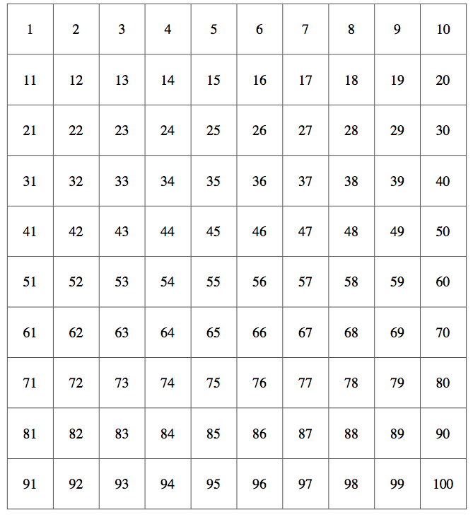

**Whole Number and Decimal**

**Place Value Chart**

|  |  |  |  |  |  |  |  |  |  |
| --- | --- | --- | --- | --- | --- | --- | --- | --- | --- |
| Millions | Hundred Thousands | Ten thousands | Thousands | Hundredsu | Tens | Ones | **.** (Decimal) | Tenths | Hundredths |
|  |  |  |  |  |  |  |  |  |  |

|  |  |
| --- | --- |
| **Operation** | **Clue Words** |
| **Add $+$** | total, sum, all together, increased by, more than, added to, combined, associative property |
| **Subtract $-$** | difference, minus, how many more, decreased by, difference between, less than, fewer than |
| **Multiply $× *$** | product, times, associative property, distributive property, commutative property, identity property |
| **Divide**    http://vhcc2.vhcc.edu/compassmath/math02/decimals/division/Division%20Def.JPG  **D**ivide  **M**ultiply  **S**ubtract  **C**heck  **B**ring Down | quotient, dividend, how many in/for each, average, divisor, dividend, remainder, out of |



**Order of Operations**

**P: ( )**

**E:**

**M: × \***

**D: ÷**

**A: +**

**S: -**

**Hundred Chart**

|  |  |  |
| --- | --- | --- |
| Greater than  > | Less than  < | Equal to  = |

**Measurement**

**Units of Measure**

* second, minute, hour
* length, width, height

English

* inch, foot, yard, mile
* cup, pint, quart, gallon
* ounce, pound, ton

Metric

* centimeter, meter, kilometer
* milliliter, liter
* gram, kilogram

|  |  |  |
| --- | --- | --- |
| 60 seconds = 1 minute | 1 cup = 8 ounces | 12 inches = 1 foot |
| 60 minutes = 1 hour | 1 pint = 16 ounces | 3 feet = 1 yard |
| 24 hours = 1 day | 1 quart = 32 ounces | 5,280 feet = 1 mile |
| 7 days = 1 week | 1 gallon = 128 ounces |  |
| 52 weeks = 1 year | 1 pound = 16 ounces |  |
| 365 days = 1 year |  |  |

**Angles**

Right

Acute

Obtuse

**Perimeter and Area**

Pe**rim**eter= Length + Length + Width + Width

(label in units)

Area= Length × Width

(label in square units)

**Fractions**

**Adding & Subtracting Fractions WITH LIKE Denominators**

* Add or subtract the numerator
* Denominator stays the same

**Mixed Numbers to Improper Fractions**

* Multiply the whole number by the denominator
* Add the product to numerator
* The sum is the new numerator and the denominator stays the same

**Adding & Subtracting Decimals**

* Line up the decimals of the number
* Add zeros to the end of each number where needed
* Add or subtract

Numerator

Denominator